**PROJECT REPORT**

**ON**

**DATING/MATRIMONIAL WEBSITE**

**(Hitch & Hugs)**

**(UNDER THE PARTIAL FULLFILLMENT OF THE**

**UNIVERSITY)**

**FOR THE COURSE T.Y.B. Sc (COMPUTER SCIENCE)**

**SUBMITTED BY:**

**SAHIL RANJAN SAHU**

**GUIDED BY:**

**PROF. PRATIKSHA HARWALKAR**

**DEPARTMENT OF COMPUTER SCIENCE**

**PARLE TILAK VIDYALAYA ASSOCIATIONS**

**MULUND COLLEGE OF COMMERCE**

**S.N. ROAD, MULUND (WEST), MUMBAI**

**UNIVERSITY OF MUMBAI**

**2020-2021**

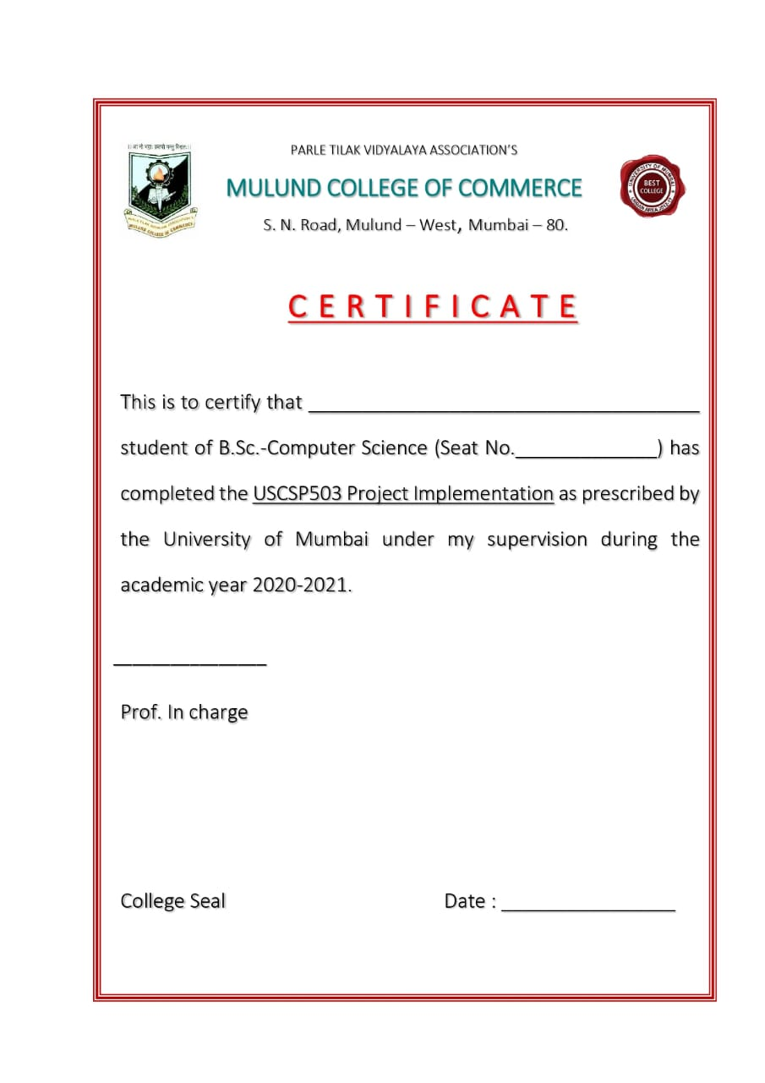

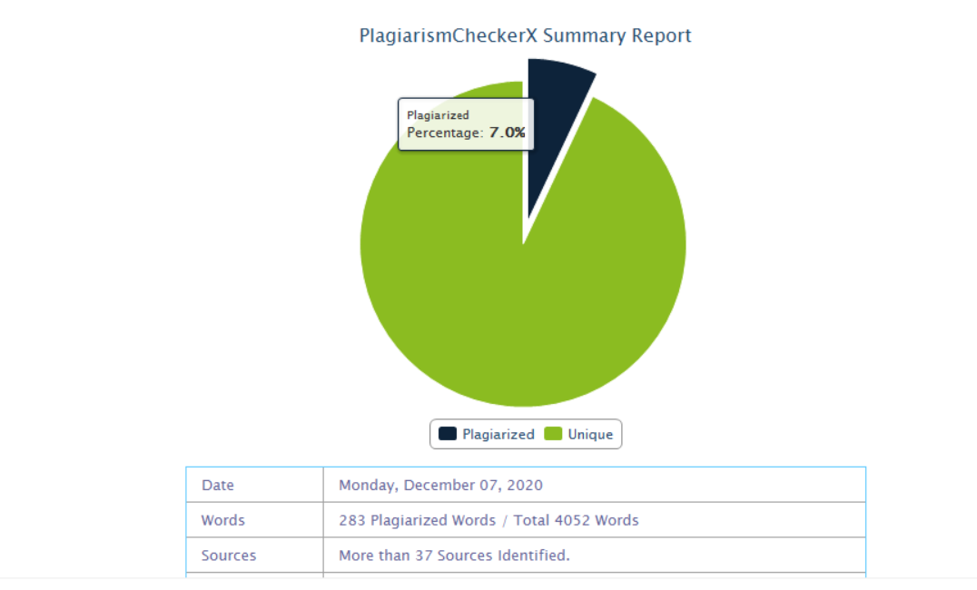

**ACKNOWLEDGEMENT**

I have a great pleasure in representing this project report entitled “**HITCH & HUGS**” and I grab this opportunity to convey my immense regards towards all the distinguished people who have their valuable contribution in the hour of need.

I like to extend my gratitude to our beloved Principal **DR. SONALI PEDNEKAR** for her timely and prestigious guidance.

I take this opportunity to thank **PROF. MRS. REENA SHAH**, Coordinator of the Department and all the professors of the Department of Computer Science of Mulund College Of Commerce, for giving me an opportunity to complete this project and the most needed guidance throughout the duration of the Programme.

I am extremely grateful to my project guide **PROF. MS. PRATIKSHA HARWALKAR** her valuable guidance and necessary support during each phase of the project. She was the source of continuous encouragement as each milestone was crossed.

A special thanks to the University Of Mumbai for having prescribed this project work to me as a part of the academic requirement in the Final year of Bachelor of Science in Computer Science.

Finally, I also owe to my fellow friends who have been a constant source of help to solve the problems that cropped up during the project development process.

**Index**

|  |  |  |
| --- | --- | --- |
| **Sr. No.** | **Topic** | **Page No.** |
| 1. | TITLE | 1 |
| 2. | INTRODUCTION | 2 |
| 3. | REQUIREMENT SPECIFICATION | 3 |
| 4. | SYSTEM DESIGN DETAILS | 4 |
| 5. | SYSTEM IMPLEMENTATION | 15 |
| 6. | RESULTS | 54 |
| 7. | CONCLUSION AND FUTURE SCOPE | 62 |
| 8. | REFERENCES | 63 |

**1. TITLE**

Title of the Project: Matrimonial/Dating Website.

Type of Project: Website Application.

Developed by: Sahil Sahu.

**2. Introduction**

For almost over a decade, matrimonial websites have been taking a huge toll in the online website category. Ever since online matrimonial sites have been introduced to the people, matchmaking has been way too easier than calling/contacting priests and pandits and relying on them for one’s better half. Relying on Pandits, priests or Family relatives is one of the oldest ways of getting your children hitched with someone for the rest of their lives, but Online matrimonial services have cut down this struggle of contacting and relying on everyone when you can do the same thing all by yourself.

People don’t really trust the matches they get online on matrimonial websites even thought the matches they come across themselves are 100% Genuine and as real as the person who’s browsing the website for matchmaking is. The orthodox thinking and a little bit backward mindset of local people has always taken the decision of online matchmaking for a toss. But, over the last few years online matchmaking and matrimonial websites have caught quite a bit of buzz in the community as a reliable companion for searching their better half.

**2.1 Features**

* Huge variety of display of various profiles.
* Attractive Page Layouts & Designs.
* Lesser unwanted input of information which can be misused.
* 100% Safety & Privacy assurance.

**2.2 Description of Current System :**

These websites are similar to the mainstream matrimonial websites where its really simple to create and maintain an account and contact with other people and other profiles. These websites have taken the basic user information input, process and display the information of other profiles on their feed through a simple algorithm.

**2.3 Limitations of Current System :**

* Involvement of Fake IDs which can access the sensitive user information aand might misuse it later on in the near future against that particular user.
* No support or positive response towards the LGBTQ+ community.
* Emphasizes majorly on the two most considered genders viz. Male & Female.

**2.4 Description of Proposed System :**

The proposed website emphasizes more on the securtiy of each user that enters and registers on it. It makes the user go through few quality checks which are essential for better security concerns. This website involves an algorithm which displays information that is processed on the basis of the gender selection of that user.

**2.5 Advantages of Proposed System :**

* Usage of more security checks inorder to ensure the secrecy and complete confidentiality of the user information.
* A huge support and hands reaching out to the LGBTQ+ community .
* Safer space for People of the Pride community and an overall, equal amount of focus over every gender type that has come up since the scrapping of Section 377 in the country.

**3. REQUIREMENT SPECIFICATIONS :**

**3.1 Software Requirement :**

* Any type of Browser (E.g.: -Google Chrome, Firefox, etc)
* Application Software :

Front-End : HTML, CSS

Back-End : PHP,SQL

**3.2 Hardware Requirement :**

* 800MHz or higher CPU
* Mali 400, Adreno 205, Tegra 2, SGX 540 or higher GPU
* Minimum Storage space (ROM) of 50-60 MB
* Minimum RAM of 512MB
* Touchpad, Gyroscope, Internet access, Keyboard.

**3.3 Data Requirement :**

* Username(String)
* Password (String)
* Email ID (String)

**3.4 Fact Finding Questions :**

* How is your website different than other Matrimonial/Dating websites ?
* Why is Gender equality in terms of matchmaking a necessity in today’s generation ?
* Is supporting the LGBTQ+ community considered as going against the culture/tradition that has been followed since the beginning of mankind?
* Is surfing your website an instigation for people with the obvious genders to lookout for other options than the obvious ones ?

**4. SYSTEM DESIGN DETAIL :**

**4.1 : Event Table :**

|  |  |  |  |  |  |
| --- | --- | --- | --- | --- | --- |
| Event | Trigger | Source | Activity | Response | Destination |
| User wants to Register. | Register | User | User enters his/her details to register | Registration of the User. | Server |
| User wants to Login. | Login | User | Checks for the correct input. | Displays the Homepage when successful. | Server |
| User wants to explore the homepage. | Clicks on the arrows on the slideshow that has been presented. | User | Previews slides as per the user clicks | Displays the slides that provide short information regarding the site. | Server |
| User wants to fill his Personal details | Clicks “My Account” on the navigation bar. | User | User enters his personal details. | Saves the user information and displays some of it on the page. | Server |
| User wants to know more about the website’s origin and motive | Clicks “About Us” on the navigation bar. | User | User can scroll through the information being shown. | Shows detailed information about the site’s origin and its motives | Server |

**Table 4.1 : Event Table for the Matrimonial/Dating Website**

**4.2 Class Diagram :**

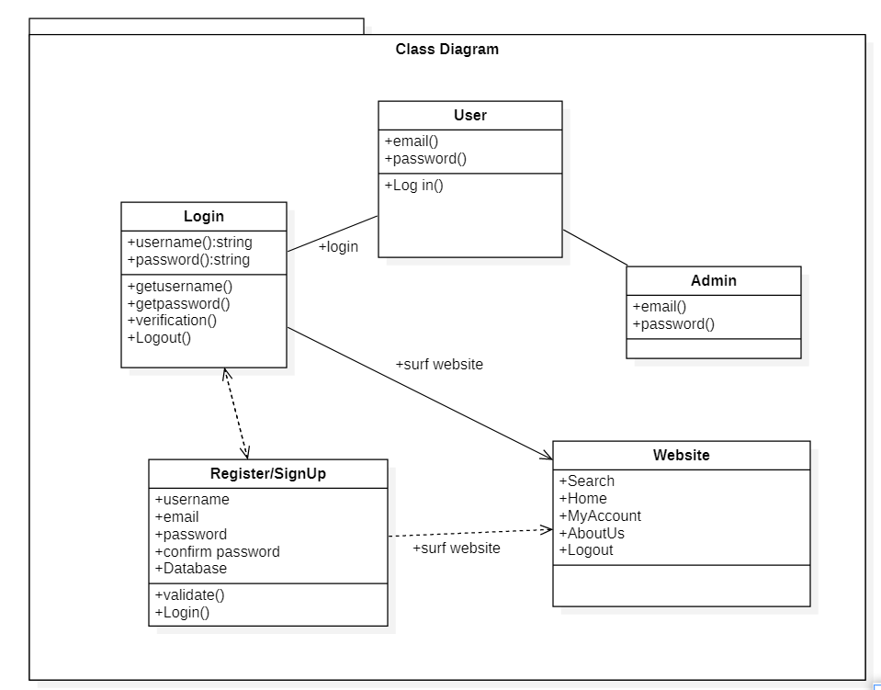

**Fig 4.2 : Class Diagram for Hitch & Hugs**

**4.3 Use Case Diagram :**

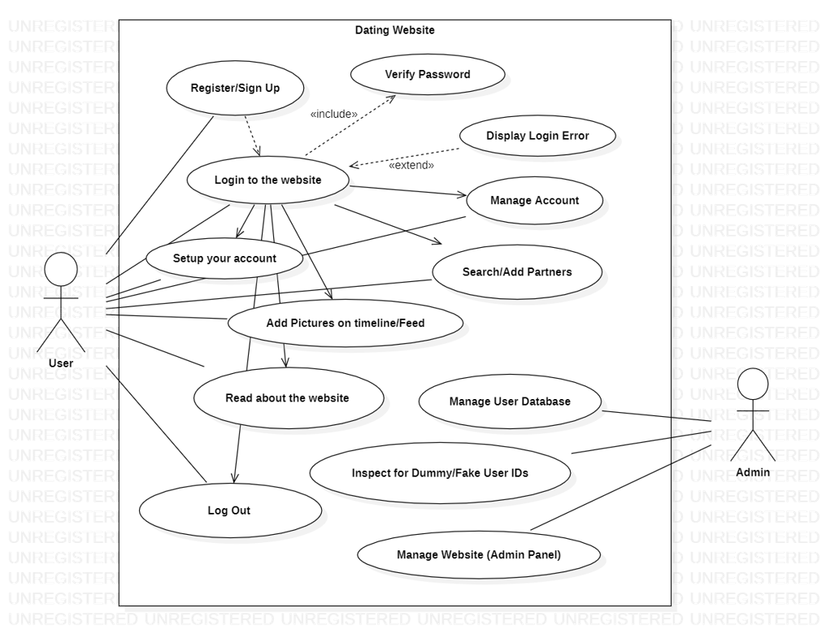

**Fig** **4.3 Use Case Diagram for Hitch & Hugs**

**4.4 Sequence Diagram :**

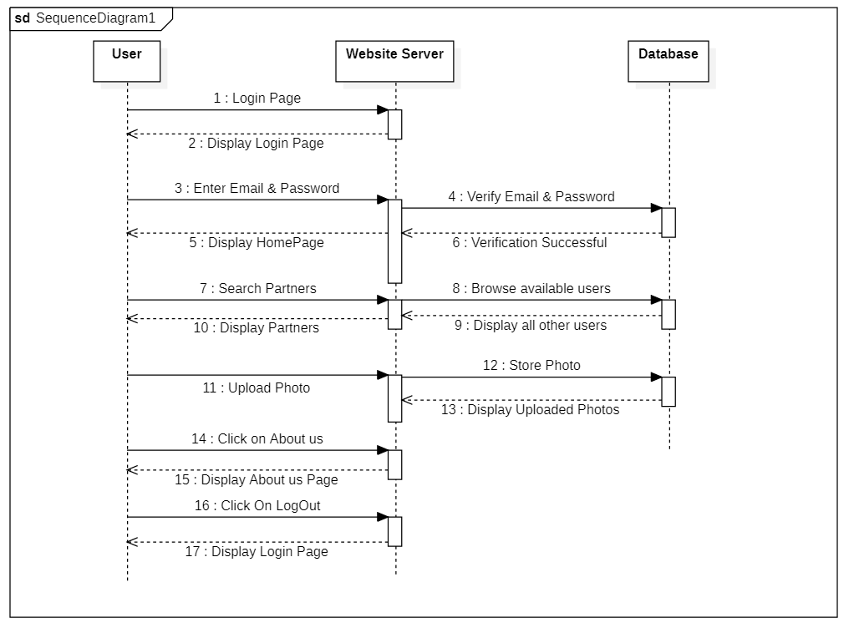

**Fig** **4.4 Sequence Diagram of Hitch & Hugs**

**4.5 Activity Diagram :**

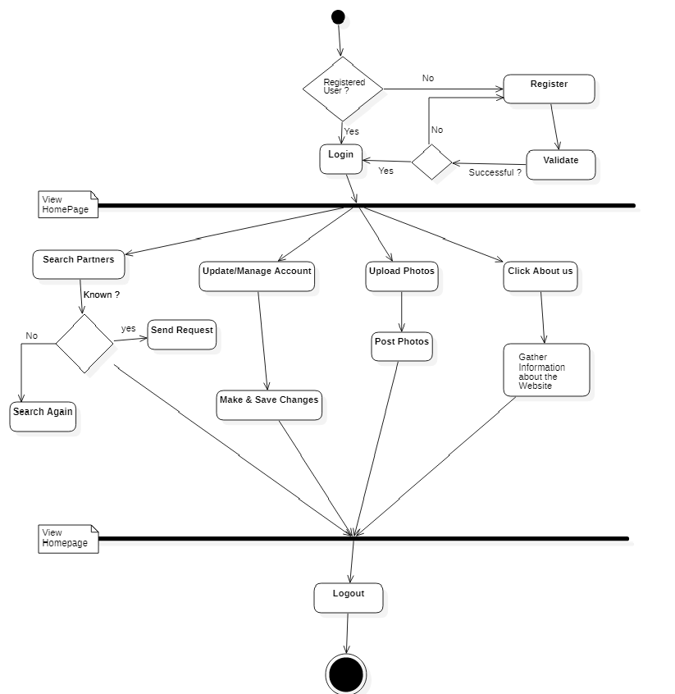

**Fig 4.5 : Activity Diagram for Hitch & Hugs**

**4.6 State Diagram :**

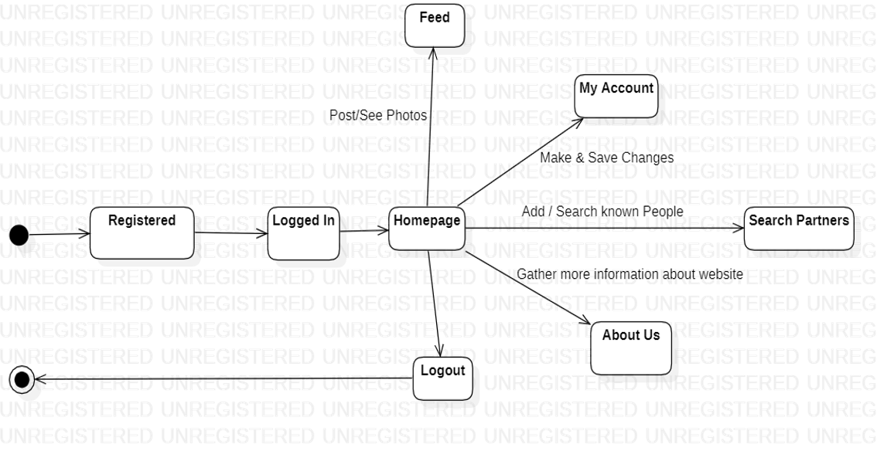

**Fig 4.6.1 : State Diagram for User Login Scenario**

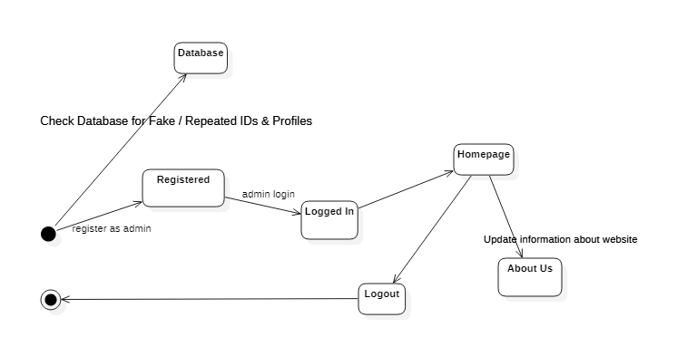

**Fig 4.6.2 : State Diagram for Admin**

**4.7 Package Diagram :**

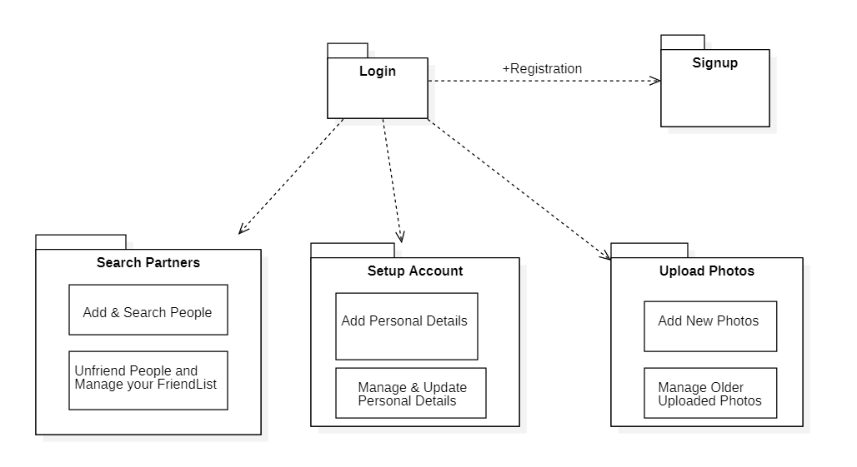

**Fig 4.7 : Package Diagram for Hitch & Hugs**

**4.8 Component Diagram :**

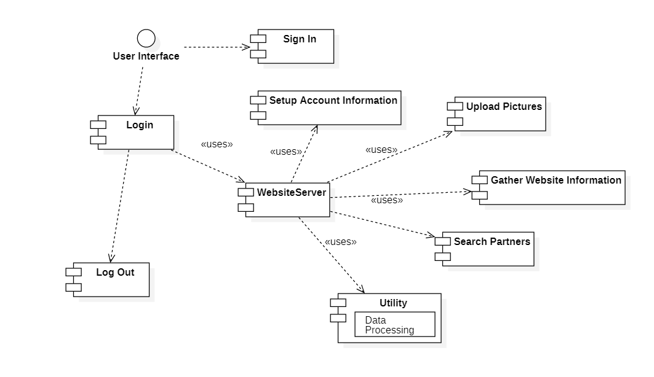

**Fig 4.8 Component Diagram for Hitch & Hugs**

**4.9 Deployment Diagram :**

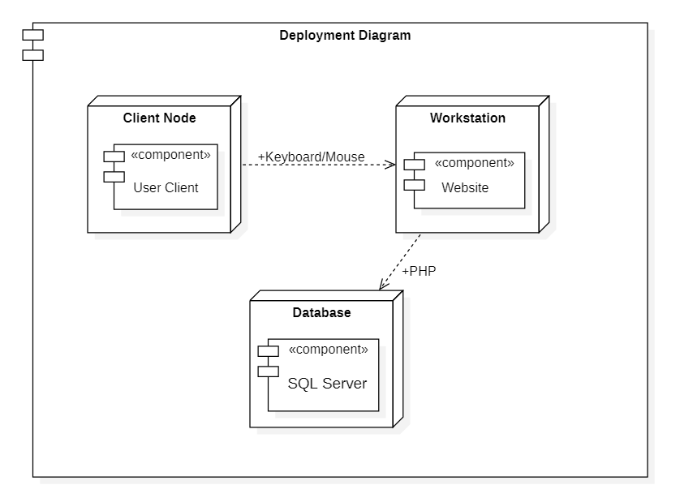

**Fig 4.9 Deployment Diagram for Hitch & Hugs**

**4.10 DATABASE DESIGN :**

**4.10.1 Database for User :**

|  |  |  |  |
| --- | --- | --- | --- |
| **Field Name** | **Data Type** | **Description** | **Attributes** |
| Username | Varchar | Stores the user name | Not null |
| Password | Varchar | Stores the password | Not null  Field size = max |
| Confirm password | Varchar | Confirms entered password | Not null  Field size=max |
| Email | Varchar | Stores Email Address | Not null  Field size = max |

**Table 4.10.1 : Database design for Hitch&Hugs**

**4.10.2 Database for Admin :**

|  |  |  |  |
| --- | --- | --- | --- |
| **Field Name** | **Data Type** | **Description** | **Attributes** |
| Email | Varchar | Stores the user Email | Not null  Field size = max |
| Password | Varchar | Stores the password | Not null  Field size = max |

**Table 4.10.2 Database for Admin & User Login**

**4.10.3 Database for User Profile Details :**

|  |  |  |  |
| --- | --- | --- | --- |
| **Field Name** | **Data Type** | **Description** | **Attributes** |
| user_name | Varchar | Stores the user name | Not null |
| user_email | Varchar | Stores User’s Email Address | Not null  Field size = max |
| user_birthdate | Date | Stores User’s Birthdate | Not null  Field size=max |
| user_gender | Enum(“Male”,  ”Female”,  ”Others”) | Stores User’s Gender | Not null  Field size = max |
| user_city | Varchar | Stores User’s City | Not null  Field size = max |
| user_state | Varchar | Stores User’s State | Not null  Field size = max |
| user_country | Varchar | Stores User’s Country | Not null  Field size = max |
| user_habits | Text | Stores User’s Habits | Not null  Field size = max |
| user_sign | Text | Stores User’s Star Sign | Not null  Field size = max |
| user_interests | Text | Stores User’s Interests | Not null  Field size = max |

**Table 4.10.3 Database for User Profile Details at Hitch&Hugs**

**5. SYSTEM IMPLEMENTATION :**

**Homepage.php [HOMEPAGE]**

<?php

session_start();

if(!isset($_SESSION['username'])){

echo "You're Logged Out";

header('location: login.php');

}

include ('dbcon.php');

include ('function.php');

?>

<html>

<head>

<title>Navbar</title>

<link rel="stylesheet" href="navbar.css">

<link rel="stylesheet" href="https://stackpath.bootstrapcdn.com/bootstrap/4.5.0/css/bootstrap.min.css" crossorigin="anonymous">

<meta charset="utf-8">

<meta name="viewport" content="width=device-width, initial-scale=1.0">

<meta http-equiv="X-UA-Compatible" content="ie-edge">

</head>

<body>

<nav class="navbar navbar-expand-lg navbar-dark bg-dark">

<a class="navbar-brand" href="#"><img src="images/NAVBARLOGO.png" alt="logo"></a>

<button class="navbar-toggler" type="button" data-toggle="collapse" data-target="#navbarNav" aria-controls="navbarNav" aria-expanded="false" aria-label="Toggle navigation">

<span class="navbar-toggler-icon"></span>

</button>

<div class="collapse navbar-collapse" id="navbarNav">

<ul class="navbar-nav ml-auto">

<li class="nav-item active">

<a class="nav-link" href="navbar.php">Home <span class="sr-only">(current)</span></a>

</li>

<li class="nav-item">

<a class="nav-link" href="profilefinal.php">My Account</a>

</li>

<li class="nav-item">

<a class="nav-link" href="about%20us.html">About Us</a>

</li>

<li class="nav-item">

<a class="nav-link" href="logout.php">Log Out</a>

</li>

</ul>

<form class="form-inline my-2 my-lg-0">

<input class="form-control mr-sm-2" type="search" placeholder="Search" aria-label="Search">

<button class="btn btn-outline-success my-2 my-sm-0" type="submit">Search</button>

</form>

</nav>

<div id="slides" class="carousel slide" data-ride="caraousel">

<ul class="carousel-indicators">

<li data-target="#slides" data-slide-to="0" class="active"></li>

<li data-target="#slides" data-slide-to="1" ></li>

<li data-target="#slides" data-slide-to="2" ></li>

<li data-target="#slides" data-slide-to="3" ></li>

<li data-target="#slides" data-slide-to="4" ></li>

</ul>

<div class="carousel-inner">

<div class="carousel-item active">

<img src="images/lgbtflag.jpg" class="d-block w-100" alt="lgbt">

<div class="carousel-caption1">

<h1> Hello <?php echo $_SESSION['username']; ?></h1>

<h1 class="display-2">Welcome to Hitch & Hugs</h1>

<h3>Where nothing overpowers "Love"</h3>

</div>

</div>

<div class="carousel-item">

<img src="images/lgbt.jpg" class="d-block w-100" alt="parishelen">

<div class="carousel-caption">

<h1 class="display-2">"LGBT"- Life Gets Better Together.</h1>

<h3>“Nature made a mistake, which I have corrected.”</h3>

<h3>“The Lord is my Shepherd and he knows I’m gay.”</h3>

</div>

</div>

<div class="carousel-item">

<img src="images/parishelen.jpg" class="d-block w-100" alt="tajmahal">

<div class="carousel-caption">

<h1 class="display-2">Paris & Helen</h1>

<h3>"The face that launched a thousand ships"</h3>

<h4>Helen of Troy is considered one the most beautiful women in all literature.</h4>

<h4>She was married to Menelaus, king of Sparta.</h4>

<h4>Paris, son of King Priam of Troy, fell in love with Helen and abducted her, taking her back to Troy. The Greeks assembled a great army, led by Menelaus's brother, Agamemnon, to retrieve Helen.</h4>

</div>

</div>

<div class="carousel-item">

<img src="images/tajmahal.jpg" class="d-block w-100" alt="parishelen">

<div class="carousel-caption">

<h1 class="display-2">Shahjahan & Mumtaaz</h1>

<h4>The promise Shahjahan made to his dead wife- Begum Mumtaz Mahal,that when she dies he would make the tomb of her grave so big and amazing that the world would lose a breath looking at the magnificent beauty, here is when he thought to start the work for his dream "Taj Mahal".</h4>

</div>

</div>

<div class="carousel-item">

<img src="images/got3.jpg" class="d-block w-100" alt="got">

<div class="carousel-caption">

<h1 class="display-2">Jon Snow & Danerys Targaryen</h1>

<h3>"Game of thrones"- An American fantasy drama television series created by David Benioff and D. B. Weiss for HBO.</h3>

<h3>The series showcased an amazing relationship between Danerys Targaryen & Jon Snow (Aegon Targaryen) who also happened to be her Nephew.</h3>

</div>

</div>

</div>

<a class="carousel-control-prev" href="#slides" role="button" data-slide="prev">

<span class="carousel-control-prev-icon" aria-hidden="true"></span>

<span class="sr-only">Previous</span>

</a>

<a class="carousel-control-next" href="#slides" role="button" data-slide="next">

<span class="carousel-control-next-icon" aria-hidden="true"></span>

<span class="sr-only">Next</span>

</a>

</div>

<script src="https://code.jquery.com/jquery-3.5.1.slim.min.js" integrity="sha384-DfXdz2htPH0lsSSs5nCTpuj/zy4C+OGpamoFVy38MVBnE+IbbVYUew+OrCXaRkfj" crossorigin="anonymous"></script>

<script src="https://cdn.jsdelivr.net/npm/popper.js@1.16.0/dist/umd/popper.min.js" integrity="sha384-Q6E9RHvbIyZFJoft+2mJbHaEWldlvI9IOYy5n3zV9zzTtmI3UksdQRVvoxMfooAo" crossorigin="anonymous"></script>

<script src="https://stackpath.bootstrapcdn.com/bootstrap/4.5.0/js/bootstrap.min.js" integrity="sha384-OgVRvuATP1z7JjHLkuOU7Xw704+h835Lr+6QL9UvYjZE3Ipu6Tp75j7Bh/kR0JKI" crossorigin="anonymous"></script>

</body>

</html>

**navbar.css [Homepage CSS] :**

@import url('https://fonts.googleapis.com/css?family=Poppins:400,500,700');

html, body{

min-height: 100%;

width: 100%;

font-family: 'Poppins',sans-serif;

}

.navbar{

padding: .8rem;

}

.navbar-nav li{

padding-right: 20px;

}

.navbar-link{

font-size: 1.1rem !important;

}

.carousel-inner img{

width: 100%;

height: 100%;

}

.carousel-caption1 {

position: absolute;

top: 50%;

transform: translateY(-50%);

transform: translateX(20%);

}

.carousel-caption1 h1{

font-size: 500%;

font-weight: 400;

text-transform: uppercase;

text-shadow: 1px 1px 12px #fff;

}

.carousel-caption1 h3{

font-size: 275%;

font-weight: 400;

text-align: center;

text-shadow: 1px 1px 8px #fff;

}

.carousel-caption {

position: absolute;

}

.carousel-caption h1{

font-size: 300%;

font-weight: 400;

text-transform: uppercase;

text-shadow: 1px 1px 15px #000;

}

.carousel-caption h3{

font-size: 200%;

font-weight: 400;

text-shadow: 1px 1px 10px #000;

}

.carousel-caption h4{

font-size: 200%;

font-weight: 450;

text-shadow: 1px 1px 15px #000;

}

.carousel-item active{

width: 100%;

height: 100%;

}

**index.php [Signup]:**

<?php

session_start();

include ('function.php');

include 'dbcon.php';

if(isset($_POST['register'])){

$username = mysqli_real_escape_string($conn,$_POST['user_name']);

$userpassword = mysqli_real_escape_string($conn,$_POST['user_password']);

$usercpassword = mysqli_real_escape_string($conn,$_POST['user_cpassword']);

$useremail = mysqli_real_escape_string($conn,$_POST['user_email']);

$pass = password_hash($userpassword, PASSWORD_BCRYPT);

$cpass = password_hash($usercpassword, PASSWORD_BCRYPT);

$emailquery = " SELECT * FROM register_user where email='$useremail'";

$res = mysqli_query($conn, $emailquery);

$emailcount = mysqli_num_rows($res);

if($emailcount>0){

echo "Email Already Exists";

}else

{

if($userpassword === $usercpassword)

{

$insertquery = "INSERT INTO register_user(user_name, user_email, user_password, user_cpassword)

VALUES ('$username','$useremail','$pass','$cpass')";

$iquery = mysqli_query($conn, $insertquery);

if($iquery)

{

echo "Inserted Successfully, Please Login now.";

// {

// $user_avatar = make_avatar(strtoupper($user_name[0]));

// $query= "UPDATE register_user SET user_avatar = '".$user_avatar."'

// where id = '".$connect->lastInsertId()."'

// ";

// $statement = $connect -> prepare($query);

// $statement->execute();

class Signup

{

private function create_userid()

{

$length = rand(4,19);

$number = "";

for($i=0; $i < $length; $i++){

#code..

$new_rand = rand(0,9);

$number = $number . $new_rand;

}

return $number;

}

private function create_url()

{

$url_address = strtolower($user_name) . "." . strtolower($user_email);

}

else{

echo "Insertion Unsuccessful";

}

}else

{

echo "Passwords don't match";

}

}

}

?>

<!DOCTYPE html>

<html>

<head>

<title>Matrimonial/Dating Website</title>

<link rel="stylesheet" href="style.css">

<?php include 'links/link.php' ?>

</head>

<body>

<div class="fresh">

<div class="sign-up-form">

<h1>Welcome to Hitch&Hugs! </h1>

<form action="<?php echo htmlentities($_SERVER['PHP_SELF']); ?>" method= "POST">

<input type="text" name="user_name" class="input-box" placeholder="Enter Username" required>

<br>

<input type="password" name="user_password" class="input-box" placeholder="Enter Password" required>

<br>

<input type="password" name="user_cpassword" class="input-box" placeholder="Confirm above Password" required>

<br>

<input type="email" name="user_email" class="input-box" placeholder="Enter Email ID" required>

<br>

<input type="checkbox"><span>I Agree to the Terms and Conditions.</span>

<br>

<button type="submit" name="register" class="signup-btn">Sign in</button>

<br>

<p>Already have an account ? <a href="login.php">Log In</a></p>

</form>

</div>

</div>

</body>

</html>

**Style.css :**

*{

margin: 0;

padding: 0;

font-family: sans-serif;

}

.fresh{

height: 100%;

width: 100%;

background-image: linear-gradient(rgba(0,0,0,0.4),rgba(0,0,0,0.4)),url(romeo.jpeg);

background-size: cover;

background-position: center;

position: absolute;

}

.sign-up-form{

width: 300px;

padding: 20px;

margin: 8% auto 0;

text-align: center;

background: transparent;

box-shadow: 0 0 3px 0 rgba(0,0,0,0.3);

color: papayawhip;

}

.sign-up-form h1

{

color:palegoldenrod;

margin-bottom: 10px;

font-size: 23px;

}

.input-box{

border-radius: 20px;

padding: 10px;

margin: 10px 0;

width: 90%;

border-top: 0;

border-left: 0;

border-right: 0;

border-bottom: 1px solid #999;

outline:none;

background: transparent;

color: white;

}

button

{

background: linear-gradient(to right, #ff105f,#ffad06);

width: 90%;

padding: 10px;

border-radius: 20px;

font-size: 15px;

margin: 10px 0;

border: none;

outline: none;

cursor: pointer;

}

img

{

width: 70px;

margin-top: -50px;

}

**Login.php:**

<?php

session_start();

?>

<html>

<head>

<title>Matrimonial/Dating Website</title>

<link rel="stylesheet" href="style.css">

<?php include 'links/link.php' ?>

</head>

<body>

<?php

include 'dbcon.php';

if(isset($_POST['login'])){

$email = $_POST['user_email'];

$password = $_POST['user_password'];

$email_search = "select * from register_user where user_email='$email' ";

$query = mysqli_query($conn, $email_search);

$email_count = mysqli_num_rows($query);

if($email_count){

$email_pass = mysqli_fetch_assoc($query);

$db_pass = $email_pass['user_password'];

$_SESSION['username'] = $email_pass['user_name'];

$pass_decode = password_verify($password, $db_pass);

if($pass_decode){

echo "Login Successful";

?>

<script>

location.replace("homepage.php");

</script>

<?php

}else{

echo "Password Incorrect";

}

}else{

echo "Invalid Email";

}

}

?>

<div class="fresh">

<div class="sign-up-form">

<h1>Welcome to Hitch&Hugs! </h1>

<form action="<?php echo htmlentities($_SERVER['PHP_SELF']); ?>" method= "POST">

<input type="email" name="user_email" class="input-box" placeholder="Enter Email ID" required>

<br>

<input type="password" name="user_password" class="input-box" placeholder="Enter Password" required>

<br>

<input type="checkbox"><span>I Agree to the Terms and Conditions.</span>

<br>

<button type="submit" name="login" class="signup-btn">Log in</button>

<br>

<p>Don't have an account ? <a href="index.php">Register!</a></p>

</form>

</div>

</div>

</body>

</html>

**Style.css [ Login ]:**

*{

margin: 0;

padding: 0;

font-family: sans-serif;

}

.fresh{

height: 100%;

width: 100%;

background-image: linear-gradient(rgba(0,0,0,0.4),rgba(0,0,0,0.4)),url(romeo.jpeg);

background-size: cover;

background-position: center;

position: absolute;

}

.sign-up-form{

width: 300px;

padding: 20px;

margin: 8% auto 0;

text-align: center;

background: transparent;

box-shadow: 0 0 3px 0 rgba(0,0,0,0.3);

color: papayawhip;

}

.sign-up-form h1

{

color:palegoldenrod;

margin-bottom: 10px;

font-size: 23px;

}

.input-box{

border-radius: 20px;

padding: 10px;

margin: 10px 0;

width: 90%;

border-top: 0;

border-left: 0;

border-right: 0;

border-bottom: 1px solid #999;

outline:none;

background: transparent;

color: white;

}

button

{

background: linear-gradient(to right, #ff105f,#ffad06);

width: 90%;

padding: 10px;

border-radius: 20px;

font-size: 15px;

margin: 10px 0;

border: none;

outline: none;

cursor: pointer;

}

img

{

width: 70px;

margin-top: -50px;

}

**dbcon.php:**

<?php

$server = "localhost";

$user = "root";

$password = "";

$db = "hitch_hugs";

$conn = mysqli_connect($server, $user, $password, $db);

if($conn)

{

?>

<script>

alert("Connection Successful");

</script>

<?php

}else

{

?>

<script>

alert("Connection Successful");

</script>

<?php

}

?>

**footer.html :**

<!DOCTYPE html>

<html lang="en" dir="ltr">

<head>

<meta charset="utf-8">

<meta name="viewport" content="width=device-width,initial-scale=1">

<title></title>

<link rel="stylesheet" href="footer.css">

<link rel="stylesheet" href="https://cdnjs.cloudflare.com/ajax/libs/font-awesome/5.11.2/css/all.css">

</head>

<body>

<div class="page-content">

<a class="page" href="about%20us.html"></a>

</div>

<footer>

<div class="footer-container">

<div class="left-col">

<img src="logo.png" alt="" class="logo">

<div class="social-media">

<a href="#"><i class="fab fa-facebook-f"></i></a>

<a href="#"><i class="fab fa-twitter"></i></a>

<a href="#"><i class="fab fa-instagram"></i></a>

<a href="#"><i class="fab fa-youtube"></i></a>

<a href="#"><i class="fab fa-linkedin-in"></i></a>

</div>

<p class="rights-text">© 2020 Created By Sahil Sahu All Rights Reserved.</p>

</div>

<div class="right-col">

<h1>Our Newsletter</h1>

<div class="border"></div>

<p>Enter Your Email to get our news and updates.</p>

<form action="" class="newsletter-form">

<input type="text" class="txtb" placeholder="Enter Your Email">

<input type="submit" class="btn" value="submit">

</form>

</div>

</div>

</footer>

</body>

</html>

**footer.css :**

body{

margin: 0;

padding: 0;

font-family: "Open Sans",sans-serif;

}

footer{

background: #f1f1f1;

padding: 90px 0;

}

.footer-container{

max-width: 1300px;

margin: auto;

padding: 0 20px;

display: flex;

justify-content: space-between;

align-items: center;

flex-wrap: wrap-reverse;

}

.footer-container .left-col .h4{

background-size: 14px;

}

.social-media{

margin: 20px 0;

}

.social-media a{

color: #001a21;

margin-right: 25px;

font-size: 22px;

text-decoration: none;

transition: .3s linear;

}

.social-media a:hover{

color: #fc5c65;

}

.right-col h1{

font-size: 26px;

}

.border{

width: 100px;

height: 4px;

background: #fc5c65;

}

.newsletter-form{

display: flex;

justify-content: center;

align-items: center;

flex-wrap: wrap;

}

.txtb{

flex: 1;

padding: 18px 40px;

font-size: 16px;

color: #293043;

background: #ddd;

border: none;

font-weight: 700;

outline: none;

border-radius: 30px;

min-width: 260px;

}

.btn{

padding: 18px 40px;

font-size: 16px;

color: #f1f1f1;

background: #fc5c65;

border: none;

font-weight: 700;

outline: none;

border-radius: 30px;

margin-left: 20px;

cursor: pointer;

transition: opacity .3s linear;

}

.btn:hover{

opacity: .7;

}

.page-content{

min-height: 100vh;

font-size: 40px;

display: flex;

align-items: center;

justify-content: center;

}

@media screen and (max-width:960px) {

.footer-container{

max-width: 600px;

}

.right-col{

width: 100%;

margin-bottom: 60px;

}

.left-col{

width: 100%;

text-align: center;

}

}

@media screen and (max-width:700px){

.btn{

margin: 0;

width: 100%;

margin-top: 20px;

}

}

**logout.php:**

<?php

session_start();

session_destroy();

header('location:login.php');

?>

**function.php:**

<?php

function.php

function make_avatar($character)

{

$path = 'avatar/'.time().'.png';

$image = imagecreate(200, 200);

$red = rand(0, 255);

$green = rand(0, 255);

$blue = rand(0, 255);

imagecolorallocate($image, $red, $blue, $green);

$textcolor = imagecolorallocate($image, 255, 255, 255);

imagettftext($image, 100, 0, 55, 150, $textcolor, 'font/arial.ttf', $character);

header('Content-type: image/png');

imagepng($image, $path);

imagedestroy($image);

return $path;

}

// function Get_user_avatar($user_id, $connect)

// {

// $query = "SELECT user_avatar FROM register_user

// where id = '".$user_id."'

// ";

// $statement = $connect->prepare($query);

// $statement->execute();

// $result = $statement->fetchAll();

// foreach($result as $row)

// {

// echo '<img src="'.$row["user_avatar"].'" width="75"

// class="img-thumbnail img-circle" />';

// }

// }

function Get_user_profile_data($id, $conn)

{

$query="SELECT * FROM register_user WHERE id = '".$id."'

";

return $conn->query($query);

}

function Get_user_profile_data_html($id, $conn)

{

$result = Get_user_profile_data($id, $conn);

$output = '<div class="table-responsive" <table class="table">

';

foreach($result as $row)

{

$output .='

<tr>

<th>Name </th>

<td>'.$row["user_name"].'</td>

</tr>

<tr>

<th>Email </th>

<td>'.$row["user_email"].'</td>

</tr>

<tr>

<th>Birth Date </th>

<td>'.$row["user_birthdate"].' </td>

</tr>

<tr>

<th>Gender </th>

<td>'.$row["user_gender"].'</td>

</tr>

<tr>

<th>City </th>

<td>'.$row["user_city"].'</td>

</tr>

<tr>

<th>State </th>

<td>'.$row["user_state"].'</td>

</tr>

<tr>

<th>Country </th>

<td>'.$row["user_country"].'</td>

</tr>

<tr>

<th>Habits </th>

<td>'.$row["user_habits"].'</td>

</tr>

<tr>

<th>Star Sign </th>

<td>'.$row["user_sign"].' </td>

</tr>

<tr>

<th>Interests: </th>

<td>'.$row["user_interests"].'</td>

</tr>

';

}

$output .= '</table> </div>';

return $output;

}

?>

**Profilefnal.php :**

<?php

// profile.php

?>

<html>

<head>

<title>My Account</title>

<link rel="stylesheet" href="navbar.css">

<link rel="stylesheet" href="https://stackpath.bootstrapcdn.com/bootstrap/4.5.0/css/bootstrap.min.css" crossorigin="anonymous">

<meta charset="utf-8">

<meta name="viewport" content="width=device-width, initial-scale=1.0">

<meta http-equiv="X-UA-Compatible" content="ie-edge">

</head>

<body>

<nav class="navbar navbar-expand-lg navbar-dark bg-dark">

<a class="navbar-brand" href="#"><img src="images/NAVBARLOGO.png" alt="logo"></a>

<button class="navbar-toggler" type="button" data-toggle="collapse" data-target="#navbarNav" aria-controls="navbarNav" aria-expanded="false" aria-label="Toggle navigation">

<span class="navbar-toggler-icon"></span>

</button>

<div class="collapse navbar-collapse" id="navbarNav">

<ul class="navbar-nav ml-auto">

<li class="nav-item active">

<a class="nav-link" href="navbar.php">Home <span class="sr-only">(current)</span></a>

</li>

<li class="nav-item">

<a class="nav-link" href="profilefinal.php">My Account</a>

</li>

<li class="nav-item">

<a class="nav-link" href="about%20us.html">About Us</a>

</li>

<li class="nav-item">

<a class="nav-link" href="logout.php">Log Out</a>

</li>

</ul>

<form class="form-inline my-2 my-lg-0">

<input class="form-control mr-sm-2" type="search" placeholder="Search" aria-label="Search">

<button class="btn btn-outline-success my-2 my-sm-0" type="submit">Search</button>

</form>

</nav>

<div class="row">

<div class="col-md-9">

<?php

if(isset($_GET["action"]))

{

if($_GET["action"] == "view")

{

?>

<div class="panel panel-default">

<div class ="panel-heading">

<div cass = "row">

<div class="col-md-9">

<h3 class = "panel-title">Profile Details</h3>

</div>

<div class="col-md-3" align="right">

<a href="profile.php?action=edit" class="btn btn-success btn-xs">Edit</a>

</div>

</div>

</div>

<div class="panel-body">

<?php

echo Get_user_profile_data_html($_SESSION["$id"],$conn);

?>

</div>

</div>

<?php

}

}

?>

</div>

<div class="col-md-3">

</div>

</div>

<script src="https://code.jquery.com/jquery-3.5.1.slim.min.js" integrity="sha384-DfXdz2htPH0lsSSs5nCTpuj/zy4C+OGpamoFVy38MVBnE+IbbVYUew+OrCXaRkfj" crossorigin="anonymous"></script>

<script src="https://cdn.jsdelivr.net/npm/popper.js@1.16.0/dist/umd/popper.min.js" integrity="sha384-Q6E9RHvbIyZFJoft+2mJbHaEWldlvI9IOYy5n3zV9zzTtmI3UksdQRVvoxMfooAo" crossorigin="anonymous"></script>

<script src="https://stackpath.bootstrapcdn.com/bootstrap/4.5.0/js/bootstrap.min.js" integrity="sha384-OgVRvuATP1z7JjHLkuOU7Xw704+h835Lr+6QL9UvYjZE3Ipu6Tp75j7Bh/kR0JKI" crossorigin="anonymous"></script>

</body>

</html>

**links.php:**

<meta charset="utf-8">

<meta name="viewport" content="width=device-width, initial-scale=1">

<link rel="stylesheet" href="https://maxcdn.bootstrapcdn.com/bootstrap/4.5.2/css/bootstrap.min.css">

<script src="https://ajax.googleapis.com/ajax/libs/jquery/3.5.1/jquery.min.js"></script>

<script src="https://cdnjs.cloudflare.com/ajax/libs/popper.js/1.16.0/umd/popper.min.js"></script>

<script src="https://maxcdn.bootstrapcdn.com/bootstrap/4.5.2/js/bootstrap.min.js"></script>

**About Us.html :**

<html lang="en">

<head>

<meta charset="UTF-8">

<meta name="viewport" content="width=device-width, initial-scale=1.0">

<title></title>

<link rel="stylesheet" href="aboutus.css">

<link rel="stylesheet" href="https://cdnjs.cloudflare.com/ajax/libs/font-awesome/5.11.2/css/all.css">

<link rel="stylesheet" href="footer.css">

</head>

<body>

<div class="page-wrapper">

<div class="about-section">

<div class="inner-container">

<h1>About Us</h1>

<p class="text">

Welcome to Hitch&Hugs. The website that has never differentiated in-between other genders, race, sexuality, caste or creed.

This website emphasizes more on making people know each other rather than making them forcefully push themselves onto

each others lives, it allows them to know each other first and work on building the bond amidst them.

The first website to ever accept the LGBTQ+ community with open arms and welcome them into the sector where

they can find their better half and feel comfortable & safe about it at the same time !

<br>

Happy Hitching & Hope you get some Hugs !

</p>

<div class="skills">

<span>Casual Dating</span>

<span>New Bondings</span>

<span>Section-377 approved!</span>

</div>

</div>

</div>

<footer>

<div class="footer-container">

<div class="left-col">

<h4 class="logo text">Hitch&Hugs</h4>

<div class="social-media">

<a href="#"><i class="fab fa-facebook-f"></i></a>

<a href="#"><i class="fab fa-twitter"></i></a>

<a href="#"><i class="fab fa-instagram"></i></a>

<a href="#"><i class="fab fa-youtube"></i></a>

<a href="#"><i class="fab fa-linkedin-in"></i></a>

</div>

<p class="rights-text">© 2020 Created By Sahil Sahu. All Rights Reserved.</p>

</div>

<div class="right-col">

<h1>Our Newsletter</h1>

<div class="border"></div>

<p>Enter Your Email to get our news and updates.</p>

<form action="" class="newsletter-form">

<input type="text" class="txtb" placeholder="Enter Your Email">

<input type="submit" class="btn" value="submit">

</form>

</div>

</div>

</footer>

</div>

</body>

</html>

**About Us.css :**

*{

margin: 0;

padding: 0;

font-family: "Open Sans",sans-serif;

box-sizing: border-box;

}

html, body{

min-height: 100vh;

display: flex;

align-items: center;

justify-content: center;

background-color: #FFE4E1;

}

.page-wrapper{

min-height: 100%;

}

.about-section{

background: url(images/hands2.jpg) no-repeat left;

background-size: 65%;

background-color: #FFE4E1;

overflow: hidden;

padding: 100px 0;

}

.inner-container{

width: 45%;

float: right;

background-color:#FFE4E1 ;

padding: 135px;

}

.inner-container h1{

margin-bottom: 30px;

font-size: 35px;

font-weight: 900;

}

.text{

font-size: 15px;

color: #555;

line-height: 30px;

text-align: justify;

margin-bottom: 20px;

}

.skills{

display: flex;

justify-content: space-between;

font-weight: 700;

font-size: 13px;

}

@media screen and (max-width:1200px){

.inner-container{

padding: 80px;

}

}

@media screen and (max-width:1000px){

.about-section{

background-size: 100%;

padding: 100px 40px;

}

.inner-container{

width: 100%;

}

}

@media screen and (max-width:600px){

.about-section{

padding: 0;

}

.inner-container{

padding: 60px;

}

}

**6. Results :**

**6.1 Validations & Naming Conventions:**

|  |  |
| --- | --- |
| Username | It should not be empty |
| Password | It should not be empty  It should match the registered password.  (User Login) |
| Confirm Password | It should not be empty  It should match the previously typed Password. |
| Email | It should not be empty.  It should match the email through which the user has registered. (User Login) |

**6.2 SCREENSHOTS :**

**6.2.1 Signup :**

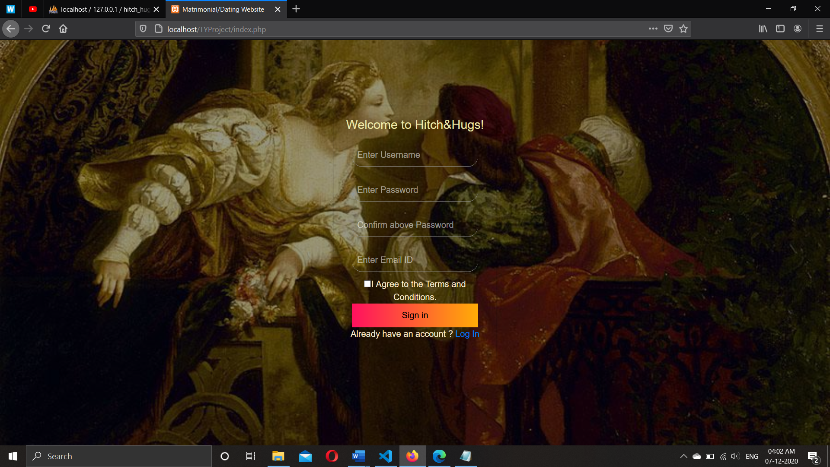

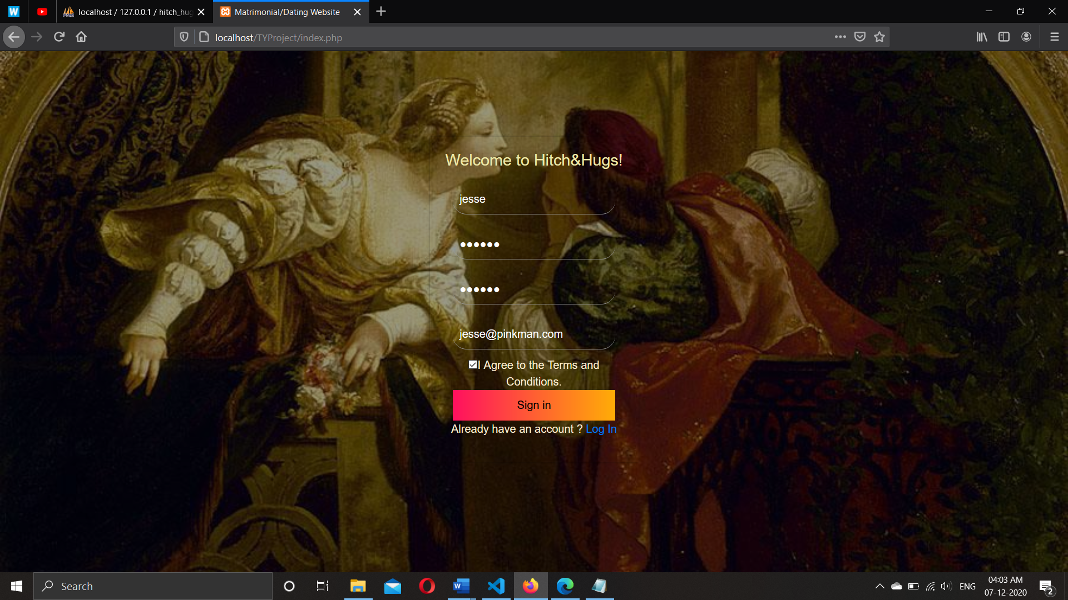

**6.2.2 After registration is successful:**

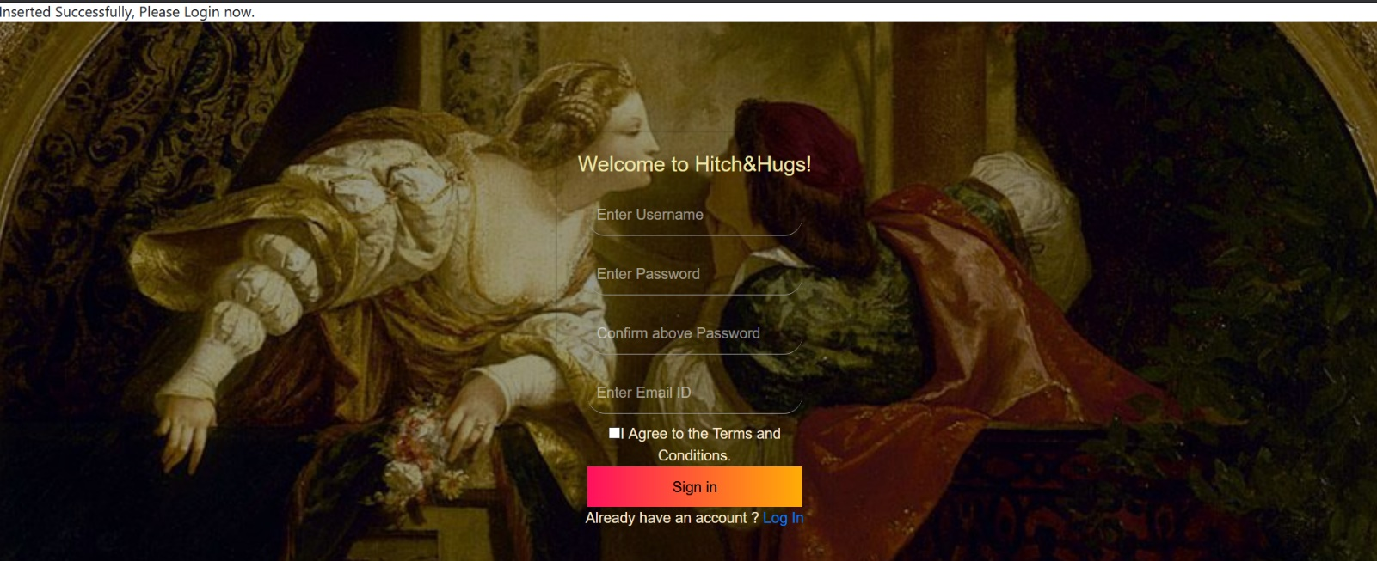

**6.2.3 Login (User & Admin) :**

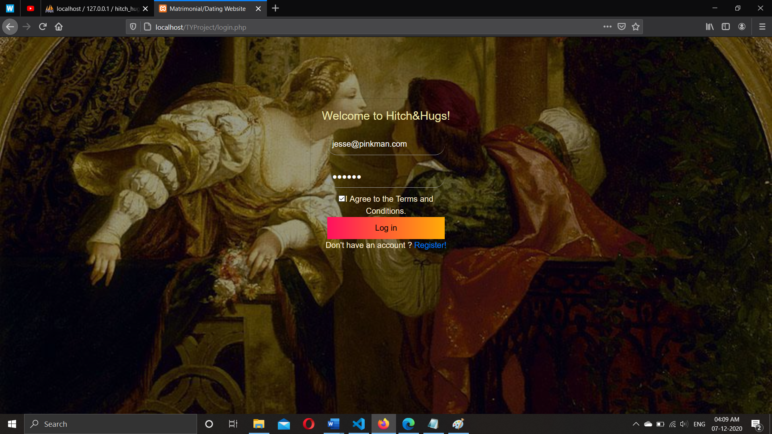

**6.2.4 After login is successful :**

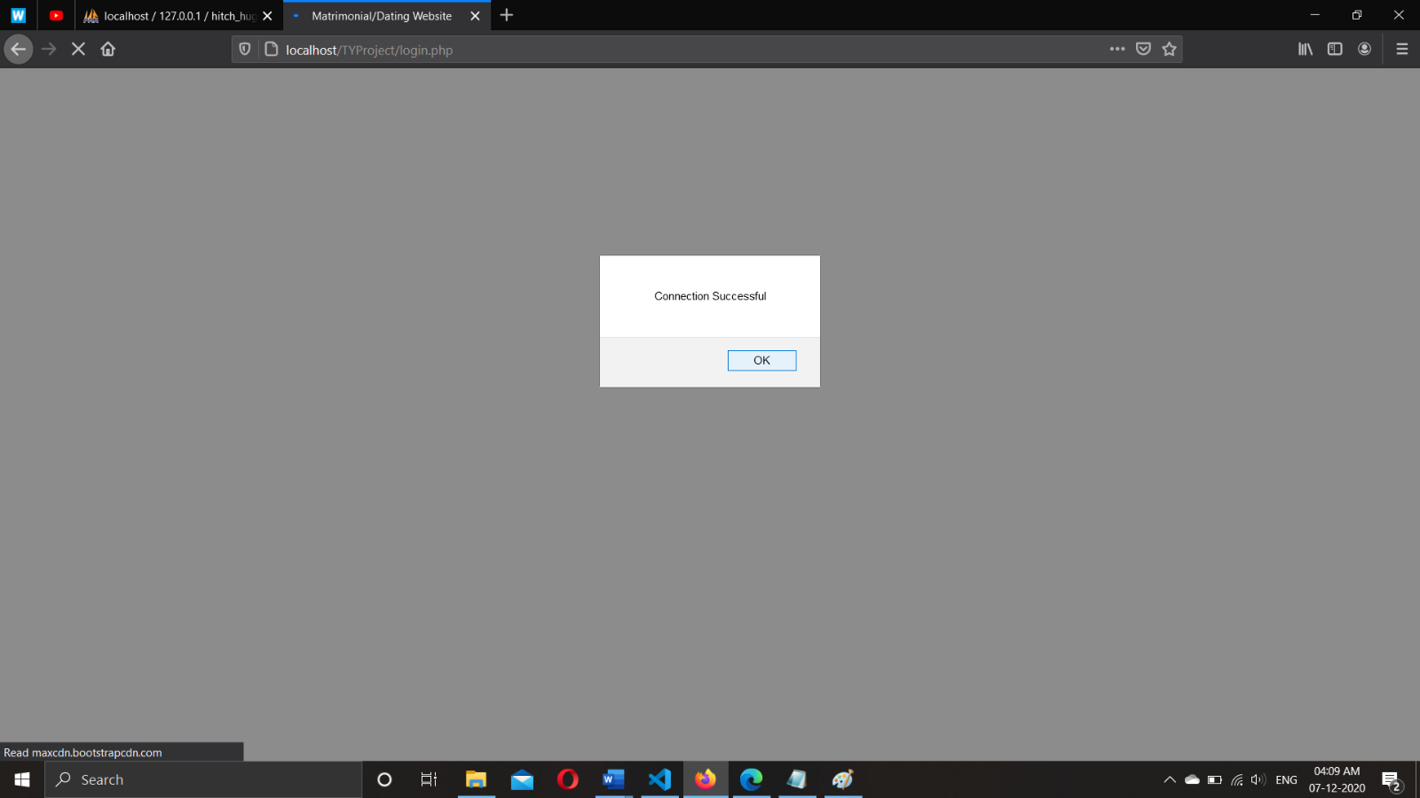

**6.2.5 Homepage :**

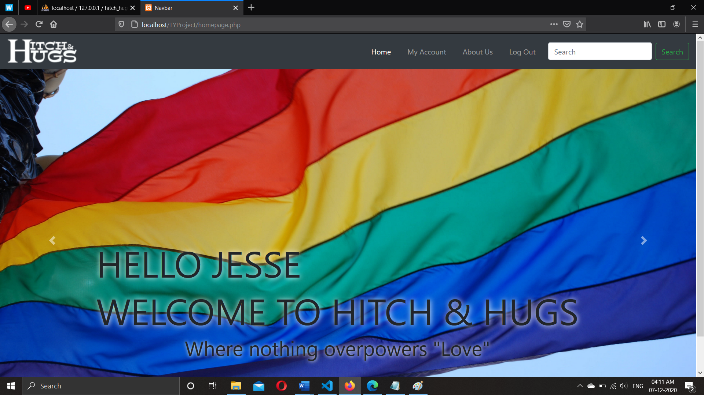

**6.2.6 Slideshow on Homepage :**

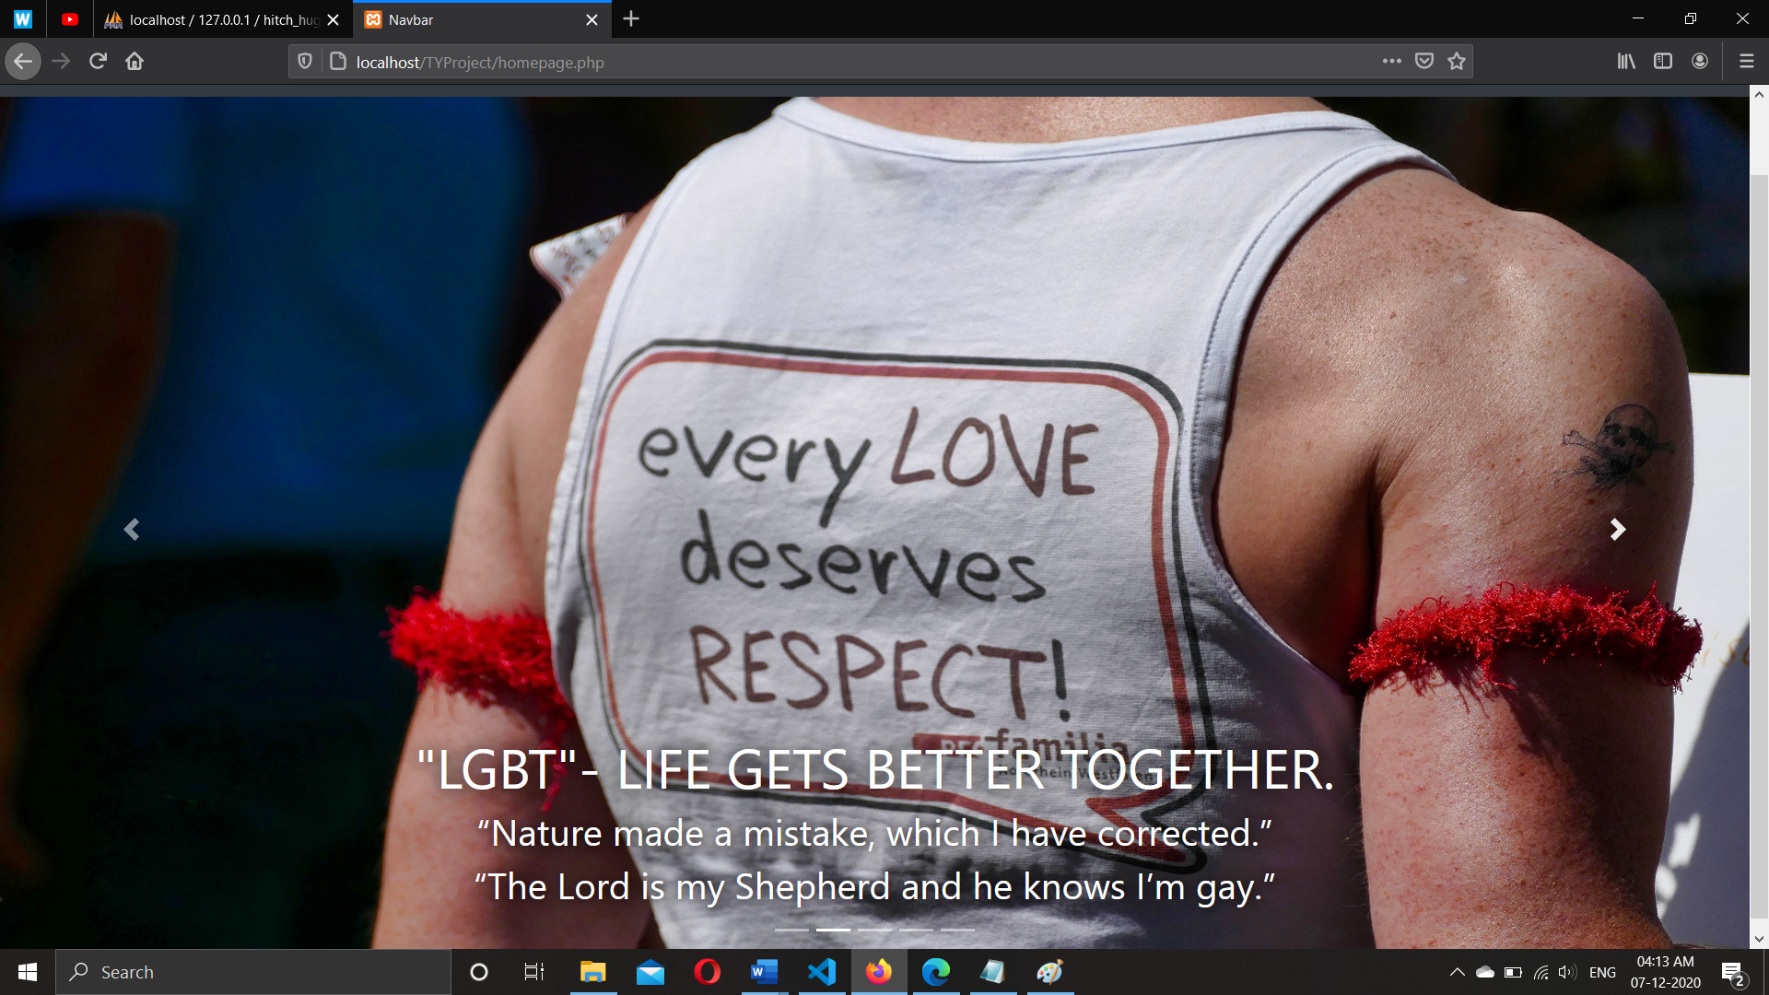

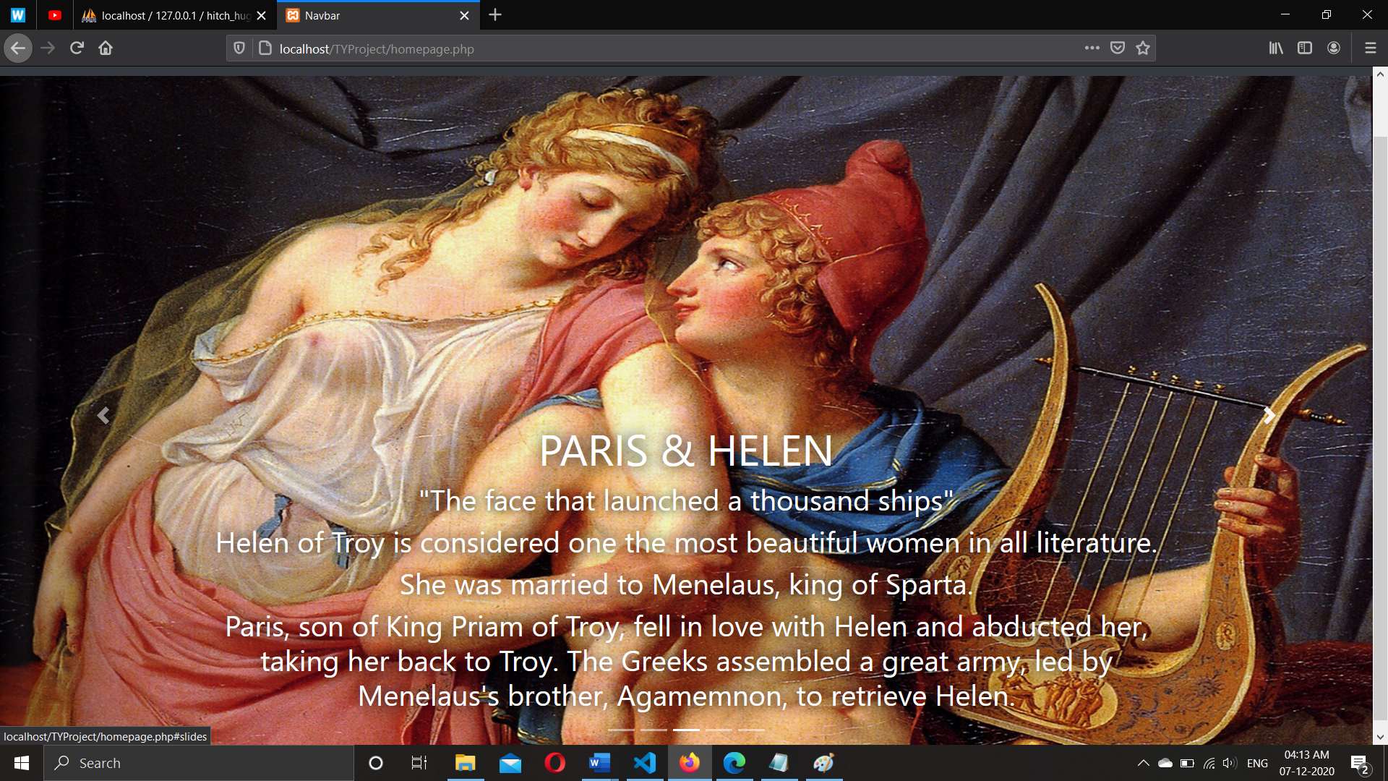

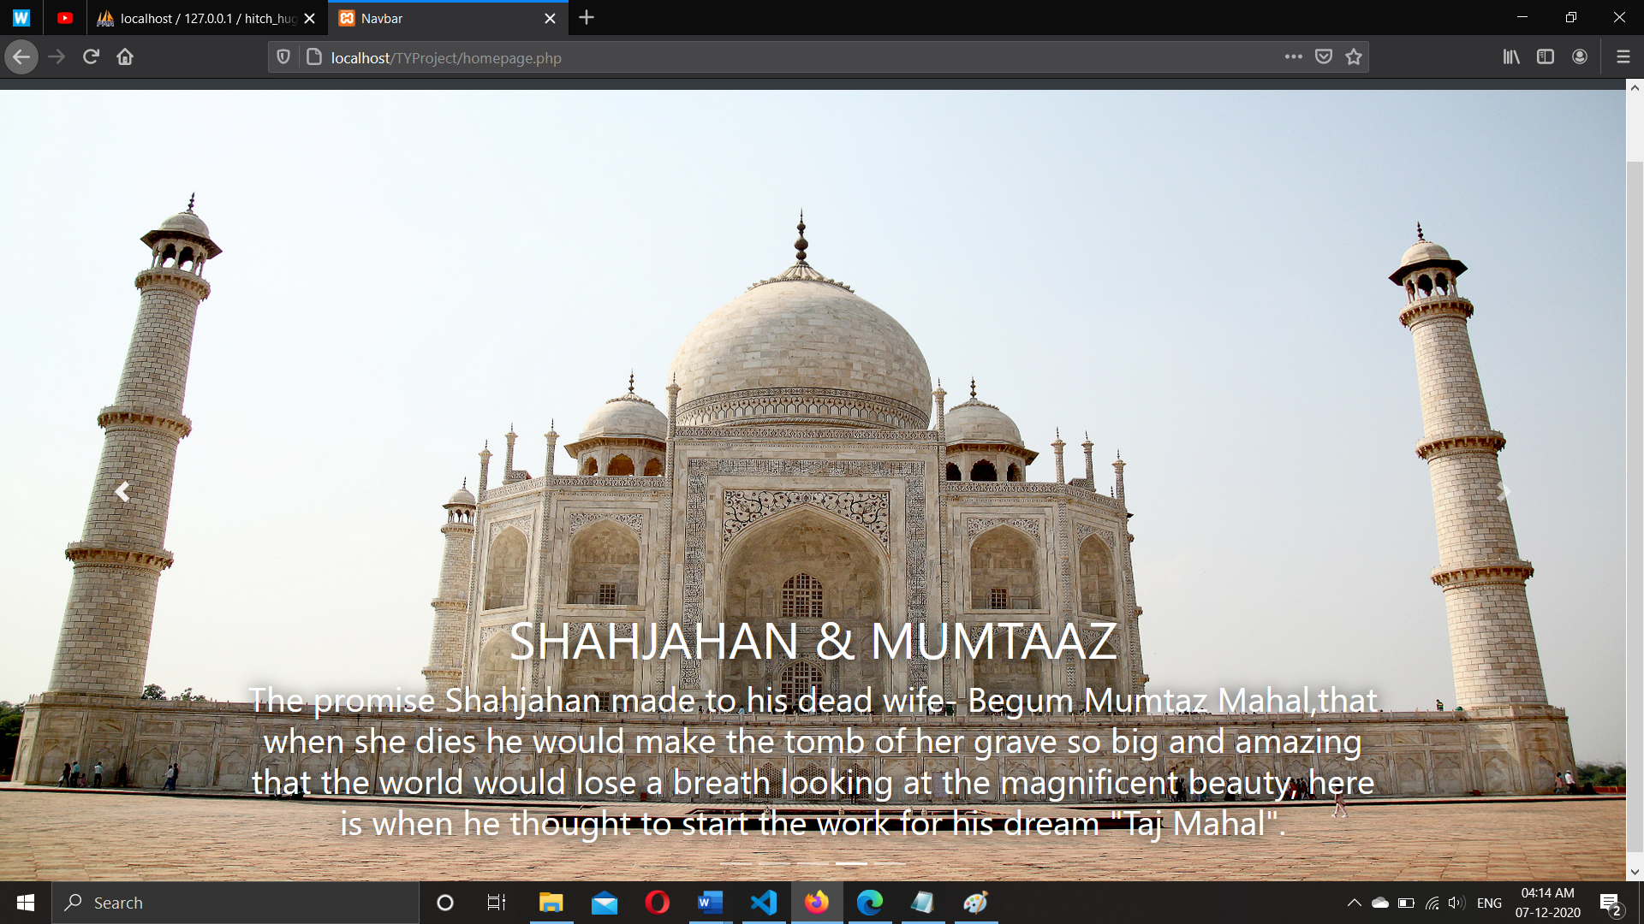

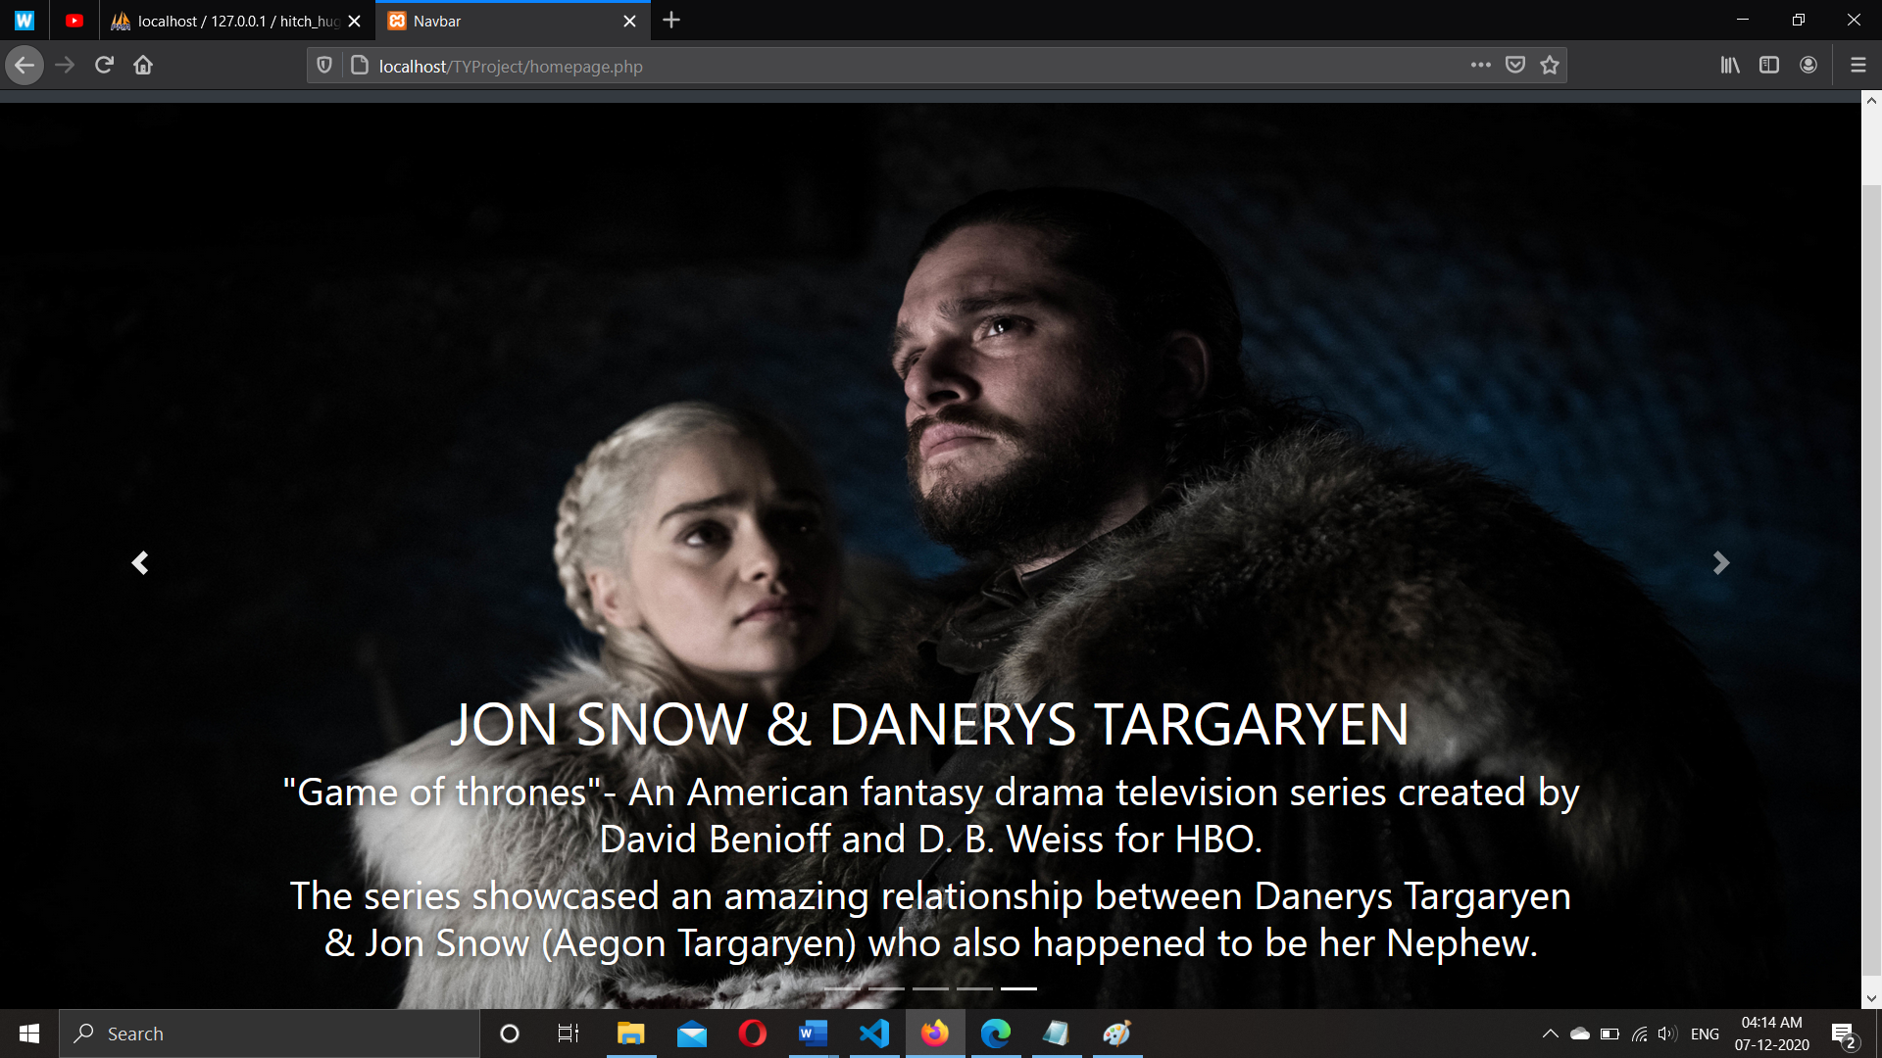

**6.2.7 About Us :**

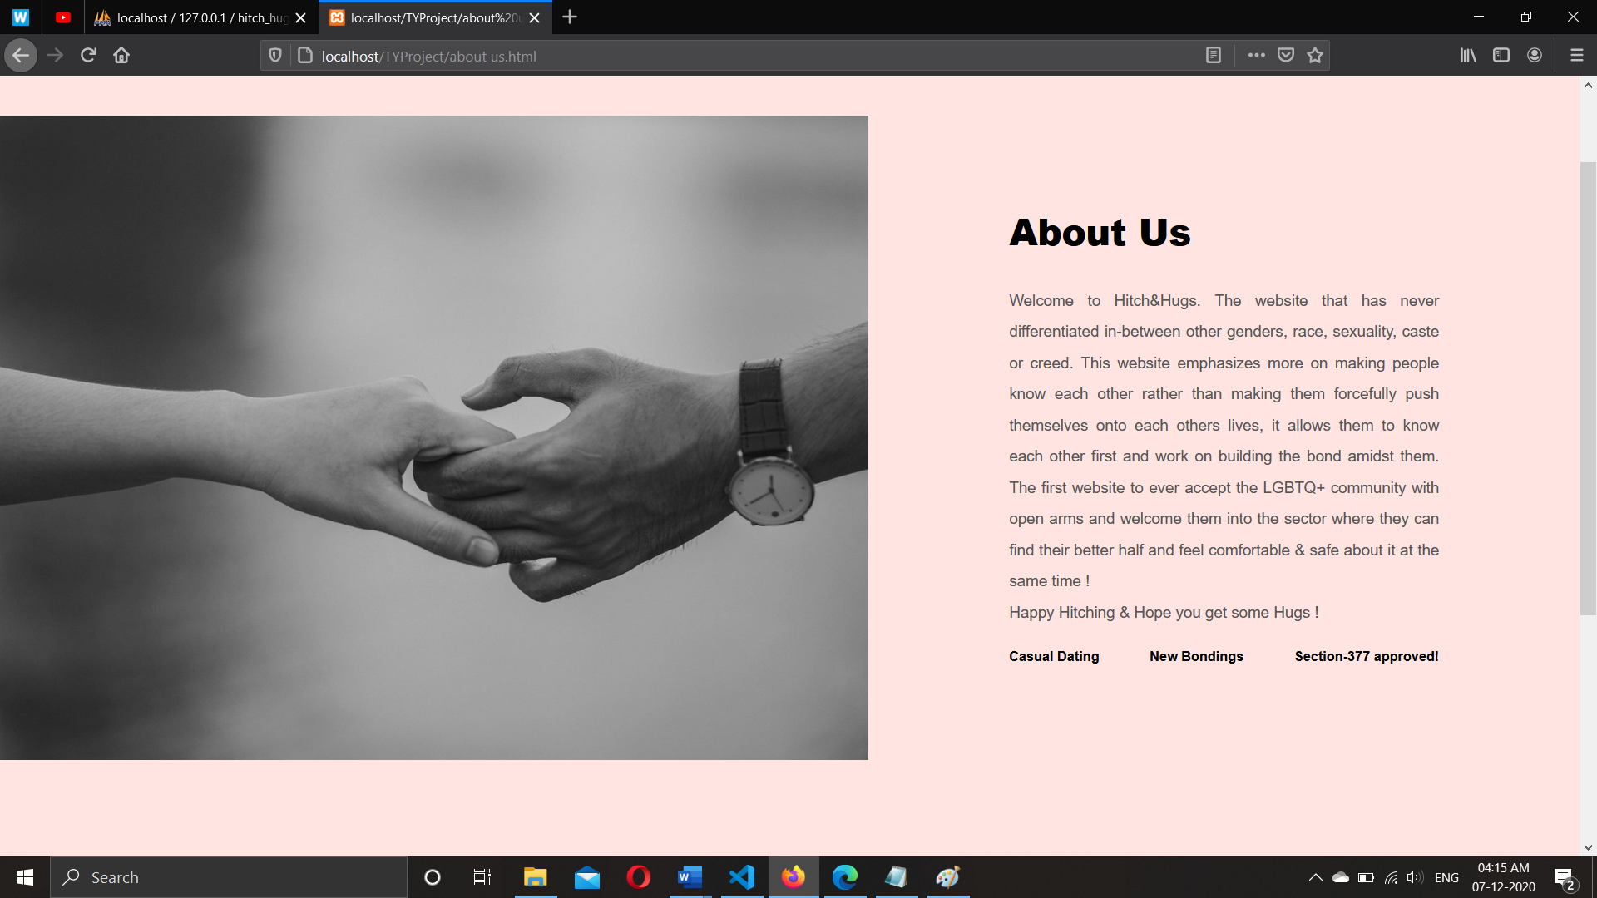

**6.2.8 Footer :**

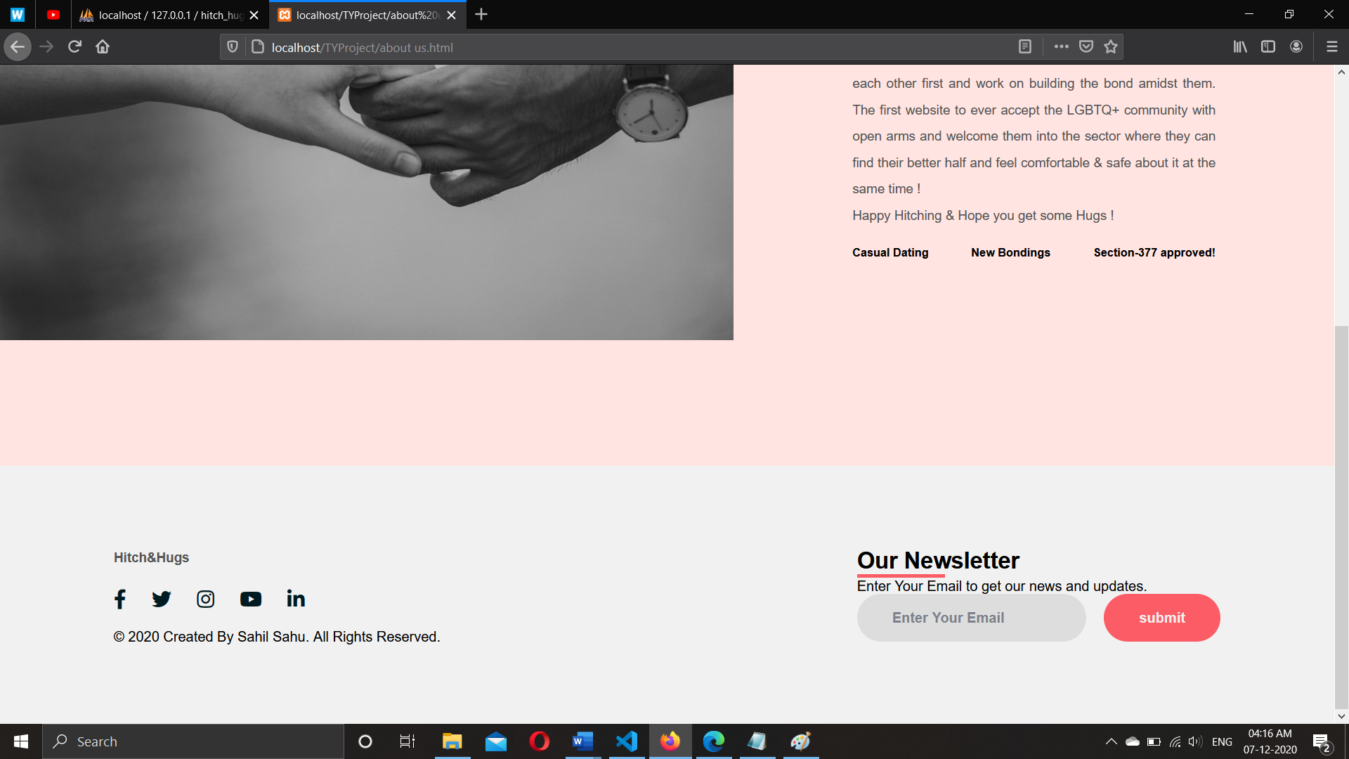

**7. CONCLUSION & FUTURE SCOPE :**

* 1. **Future Enhancements :**
* Adding a better UI to improve user experience.
* Adding a Friend Request System.
* Adding Live Message Chat window.
* Adding Video Calling Window.
* Adding Premium Membership.
* Putting in more notifications about Alerts and Updates.
* Advancing in Encryption standards.
* Putting user support.
* Easier interface.
  1. **Conclusion :**
* The approach of this website was to provide an easier way for the users to meet new people and connect with them without having to be actually anxious while meeting them in real life.
* The purpose of choosing website was because of the easier programming languages
* With the feedback provided by my classmates, teachers and fellow guides there is still a he scope of advancement and improvement.
* The idea of this project was duly appreciated by them.

**8. References :**

* <https://stackoverflow.com/>
* <https://creately.com/>
* <https://www.w3schools.com/>
* <https://www.youtube.com/>
* <https://www.indiastudychannel.com/>
* <https://www.webslesson.info.com/>

**9. Annexure :**

**9.1 List of Figures :**

|  |  |  |
| --- | --- | --- |
| **Figure No.** | **Figure Name** | **Page No.** |
| 4.2 | Class diagram for Hitch & Hugs | 5 |
| 4.3 | Use case diagram for Hitch & Hugs | 6 |
| 4.4 | Sequence diagram for Hitch & Hugs | 7 |
| 4.5 | Activity diagram for Hitch & Hugs | 8 |
| 4.6 | State diagram for User scenario. | 9 |
| 4.6 | State diagram for Admin scenario | 9 |
| 4.7 | Package diagram for Hitch & Hugs | 10 |
| 4.8 | Component diagram for Hitch & Hugs | 11 |
| 4.9 | Deployment diagram for Hitch & Hugs | 12 |
| 6.2.1 | Screenshot for SignUp Page | 56 |
| 6.2.2 | Screenshot for After registration is successful | 57 |
| 6.2.3 | Screenshot for LOGIN (User & Admin) page | 57 |
| 6.2.4 | Screenshot for After login is successful | 58 |
| 6.2.5 | Screenshot for Homepage | 58 |
| 6.2.6 | Screenshot for Slideshow on HomePage | 59 |
| 6.2.7 | Screenshot for About Us Page | 61 |
| 6.2.8 | Screenshot for Footer | 61 |

**9.2 LIST OF TABLES:**

|  |  |  |
| --- | --- | --- |
| **Table No.** | **Name of the table** | **Page no** |
| 4.10.1 | Event table | 4 |
| 4.10.1 | Database design for User Login | 13 |
| 4.10.2 | Database design for Admin Login | 13 |
| 4.10.3 | Database design for User Profile Details | 14 |
| 6.1 | Validation & naming Conventions | 54 |